July 17, 2017
Presented by: James R. Herron
FosTech Solutions Inc.

Adding Groups to AVP

If you have certain participants that you would like to show up in the same list, you can add them to a group. Groups are great for separating participants into things like program year, field offices, or any other reason you want them to show together. Before you can do that, however, you will need to create the group. Here are the steps you need to take to create one.

- On the participants screen, right-click on a participant. In this menu, you will see an option to “Add to Group”, mouse over that. Next you will see the available groups, and an option to create a new one (<New Group>). Click on New group.
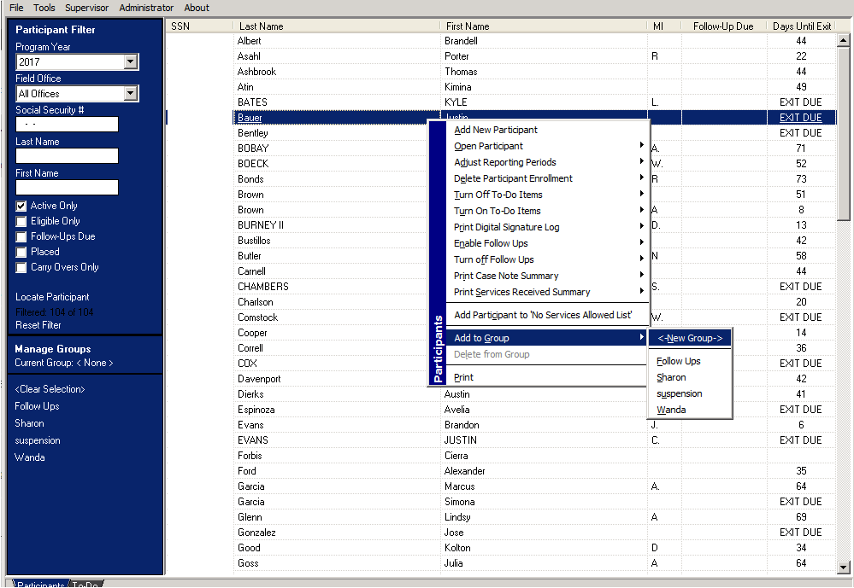
- Next, a dialog box with come up. This will allow you to name the group. We suggest as specific a name as you can enter, this way it will limit any confusion in the future.
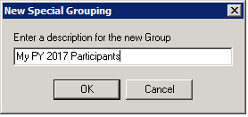
- Once you have the group created, go back to the Participants screen. Right-click on all of the participants you want added to the group. The same menu as before will pop up, only this time add them to the group instead of making a new one.
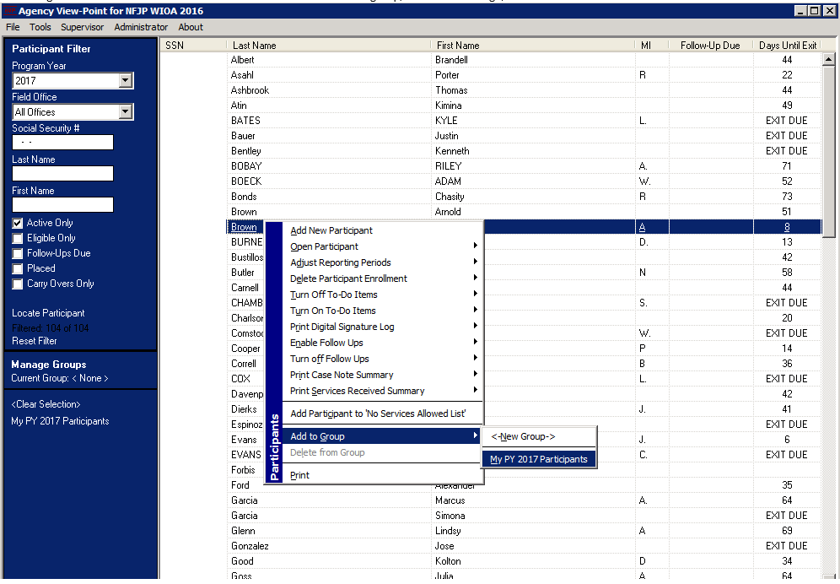
- Once you have all the participants added to the group, you can see only them by clicking on the group name. Your groups can be found at the bottom of the menu on the left side of the screen, under “Manage Groups”.
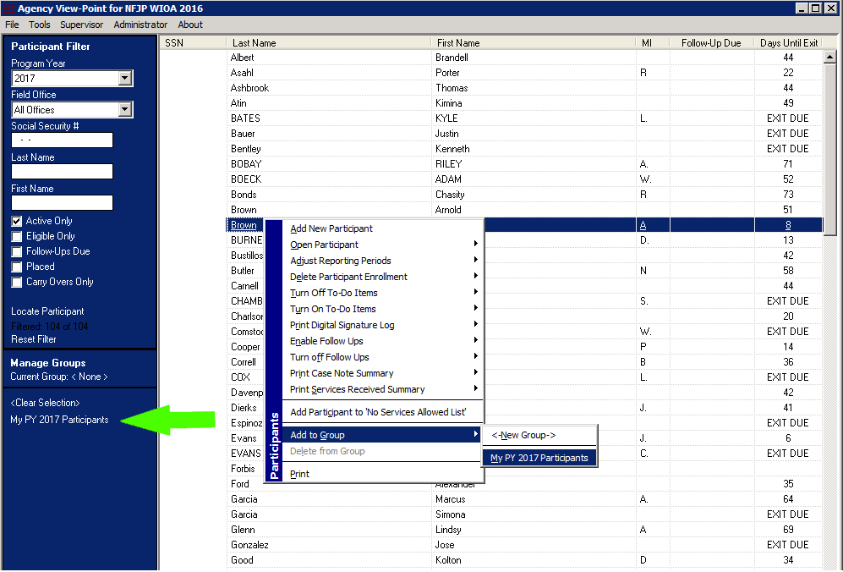
This concludes the instructions on how to add groups to AVP. If you have further questions, please don’t hesitate to ask.

